**Introduction**

The purpose of this experiment was to learn whether going on social media right when I wake up while in bed would affect how fresh and rested I felt during the day. In accordance with the ‘“Leave your smartphone out of bed”: quantitative analysis of smartphone use effect on sleep quality’ (Kheirinejad et al., 2022) I hypothesized that scrolling on social media right when I wake up while still in bed for even 30 minutes would make me feel less rested and fresh throughout the day.

**Methods**

Within a span of two weeks, I did the intervention (scrolling on Instagram and TikTok) on six distinct days, dedicating a minimum of 30 minutes each time. I made sure to try and keep the variables surrounding the intervention the same by scrolling around the same time in the same conditions. Another measure I took to factor in some limitations from previous studies was to try and keep the amount of sleep I got constant by sleeping and waking up around the same time every day. I diligently noted my mood levels every night before sleeping on a scale ranging from 1 to 7 in a notebook. These evaluations were then uploaded via a google form on the last day. This allowed me to determine how fresh and rested I felt when I woke up following the intervention (n=6) and on the days without (n=6).

**Results**

On days I didn't use social media when I woke up how fresh and rested I felt throughout the day had a mean of 6.167 and standard deviation of ​​0.373, as compared to on the days I did the score was at 3.67 and the standard deviation was 0.943.

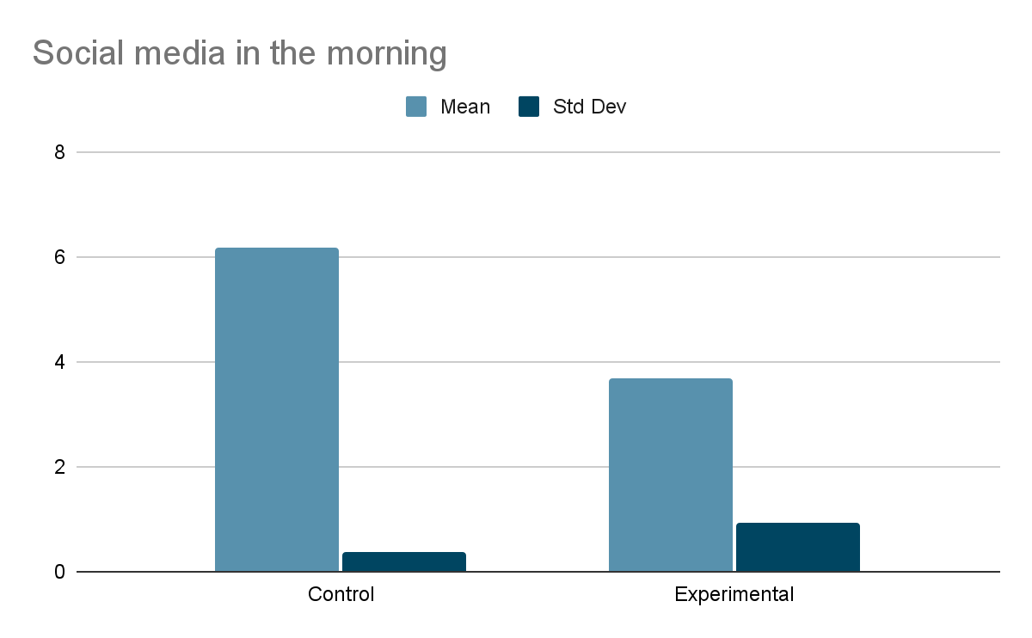

**Discussion**

The results from my experiment seem to indicate a noticeable deterioration in how fresh and rested I felt on days I used my phone to scroll on social media right when I woke up. This supports my initial hypothesis that scrolling on social media first thing in the morning, in this case, even for 30 minutes, can negatively influence how fresh and rested I feel throughout the day. The decrement from 6.167 to 3.67, is significant enough to warrant the potential drawbacks of the intervention.

However, looking at the standard deviation we can see that the deviation almost tripled from 0.373 to 0.943 (control vs experiment) this means that there could been several other factors affecting the data during the experimental days increasing the variability so it's important to consider confounding variables that may have influenced these outcomes. For instance, the total amount of screentime I had that day, whether or not I had a headache or was feeling unwell, or if I was celebrating Thanksgiving with my friends.

In conclusion, while there seems to be a negative correlation between social media first thing in the morning and feeling rested and fresh throughout the day based on my results, it's evident that numerous variables can influence this relationship. Moving forward, it is imperative to extend the study period, reduce the confounding variables, and repeat the study under better conditions. Personally, these results inspire a commitment to continue trying to avoid using my phone and going on social media right as soon as I wake up as a means to feel more rested the fresh in the day.

**Bibliography**:

Kheirinejad, S., Visuri, A., Ferreira, D., &amp; Hosio, S. (2022). *“leave your smartphone out of bed”: Quantitative analysis of smartphone use effect on sleep quality.* Personal and Ubiquitous Computing, 27(2), 447–466. https://doi.org/10.1007/s00779-022-01694-w